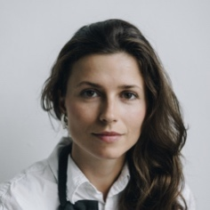

**Education**

**Speciality, degree** | 2012–2016

Kaunas University of Technology

Study modules required for position.

Awards, participation in the Olympiad, etc. (for example, Rector’s acknowledgement for the participation in the project X (09 2015))

**Work experience**

**Position** | 09 2015 – 09 2016

Employer

List of responsibilities (for example, production distribution in Lithuania, advertisement strategy, communication with buyers and search of potential customers)

**Volunteer** | 03 2015 – 09 2015

Institution / Organisation of Volunteering

Responsibilities and activities.

**Additional information**

Publications, scientific presentations, participation in projects, conferences, courses   
and seminars.

**Languages**

Lithuanian – excellent

English – excellent

Russian – good

German – basic

**Name Surname**

I am a careful and diligent graphic designer who has mastered the Adobe Creative Suite program and website design. I want to make fast, smart decisions on the position of the graphic designer in your company. I have a Bachelor's degree in Graphic Arts Engineering.

**Skills and competencies**

Adobe Photoshop,

Adobe Premiere,

Adobe Illustrator,

CorelDRAW

**Contacts**

+370 (123) 45 678

Name.surname@gmail.com

Address, Kaunas